**Q.1**

**public** **class** Arithmetic {

**public** **static** **void** main(String[] args)

{

myAdd addition = **new** myAdd() {

**public** **int** add(**int** a, **int** b) {

**return** (a+b);

}

};

System.***out***.println("Addition =>"+addition.add(10,20));

mySub Substraction = **new** mySub() {

**public** **int** add(**int** a, **int** b) {

**return** (a-b);

}

};

System.***out***.println("Substraction =>"+Substraction.add(10,20));

myMul Multiplication = **new** myMul() {

**public** **int** add(**int** a, **int** b) {

**return** (a*b);

}

};

System.***out***.println("Multiplication =>"+Multiplication.add(10,20));

myDiv Divide = **new** myDiv() {

**public** **int** add(**int** a, **int** b) {

**return** (a/b);

}

};

System.***out***.println("Division =>"+Divide.add(10,20));

}

}

@FunctionalInterface

**interface** myAdd

{

**int** add(**int** a, **int** b);

}

**interface** mySub

{

**int** add(**int** x, **int** y);

};

**interface** myMul

{

**int** add(**int** x, **int** y);

};

**interface** myDiv

{

**int** add(**int** x, **int** y);

}

OUTPUT:

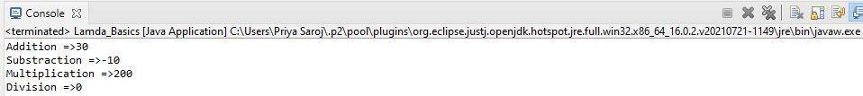

Q.2

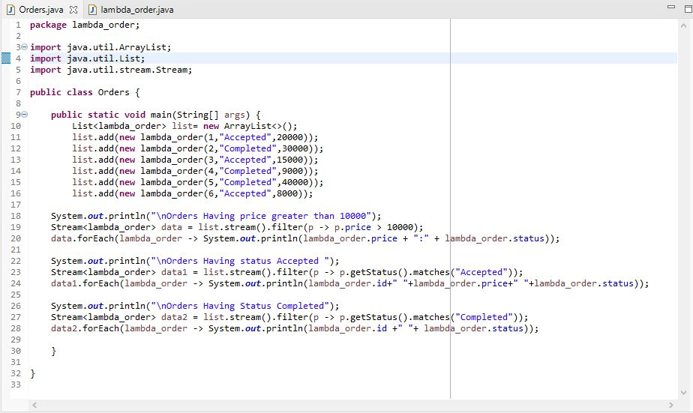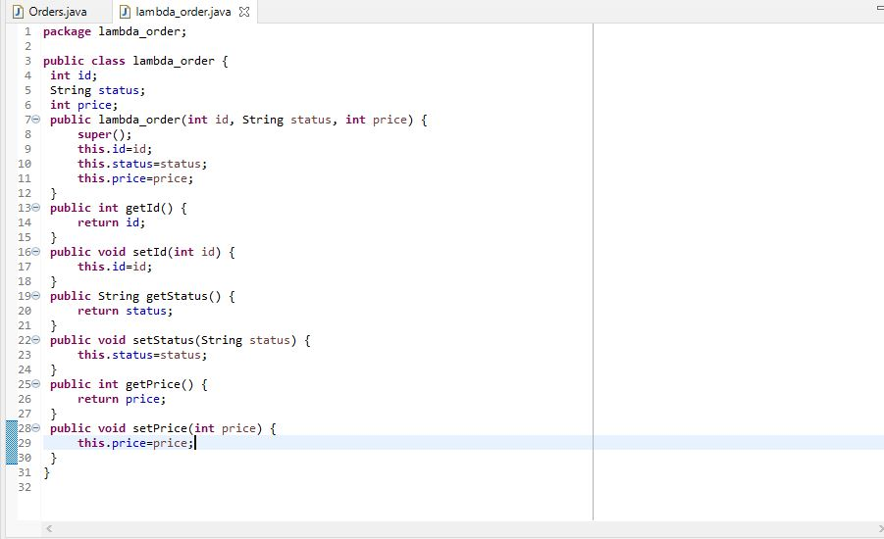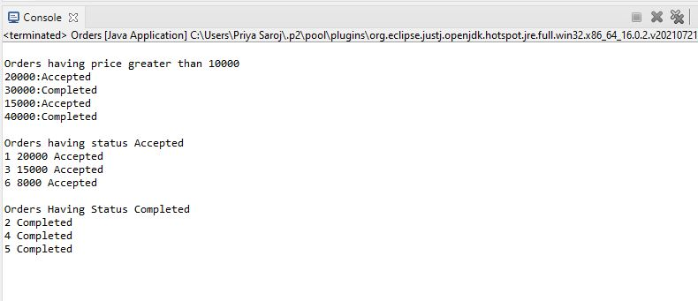

Q.3

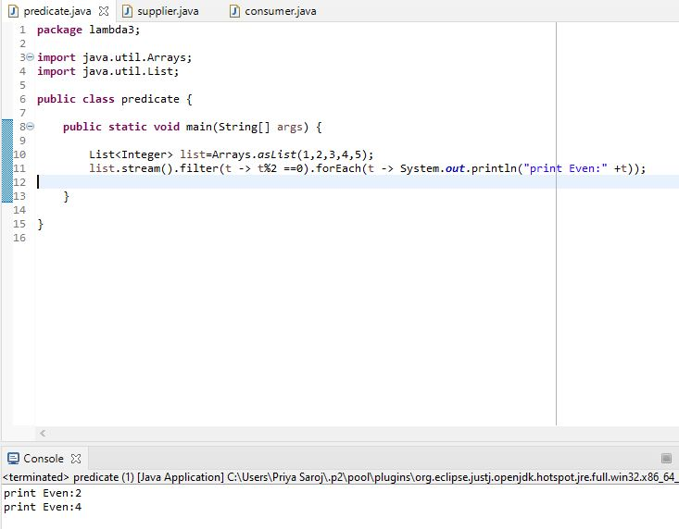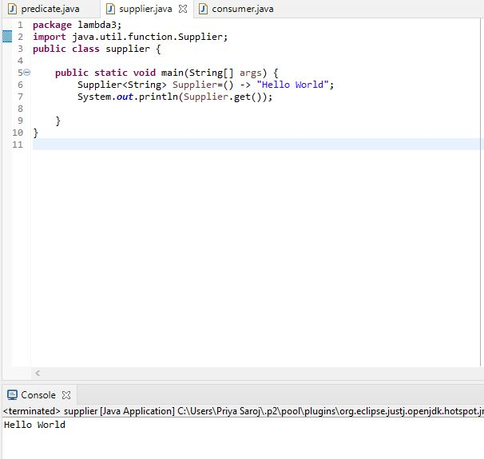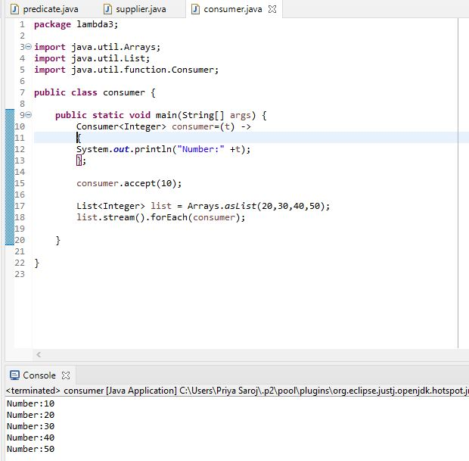

Q.4

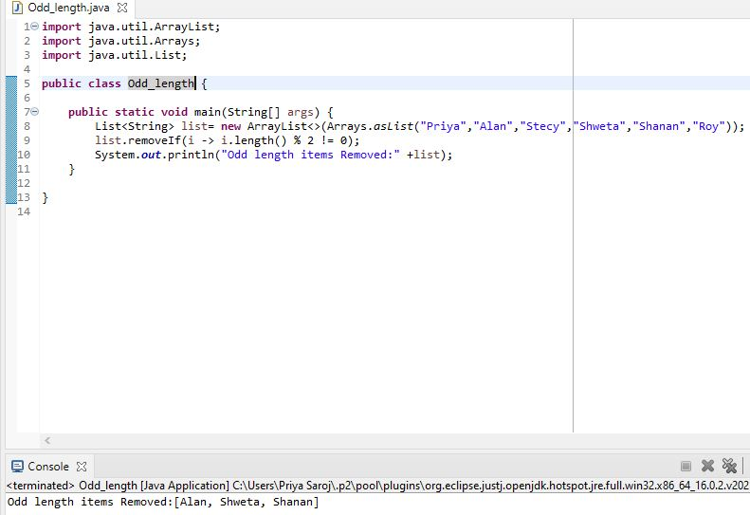

Q.5

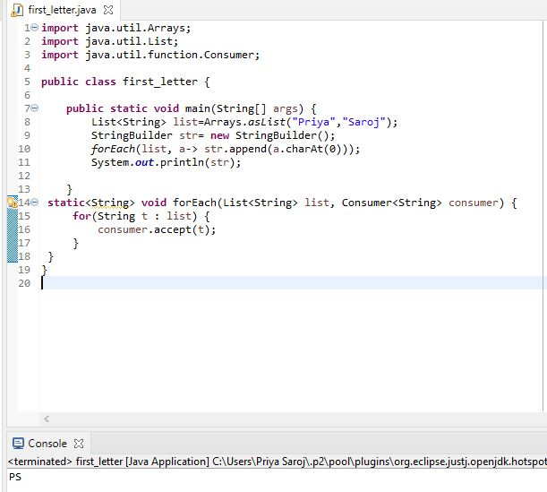

Q.6

